**Commentary on BIC02: Reduction of Number of Face to Face Visits**

At is meeting on 05 September 2022, the Panel requested that the Head of Business Improvement provide further information regarding indicator BIC025.

**Response:**

The City Council's face to face service moved into the Westgate Library from January 2022.

The graph below is useful as it tracks the volumes of visits this year and last year:

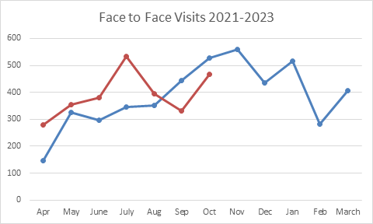

For September and October the overall number of visits has been less than last year. The main increases were from June through to August although July saw the most significant increase which can be attributed to visits about Council Tax mainly due to queries relating to the £150 energy rebate but some also relating to the backlog of work in Financial Services. Queries relating to Housing Needs was also at its highest throughout July. Our customer satisfaction levels have remained strong throughout with 95% of customers rating our service as Good or Average year to date.